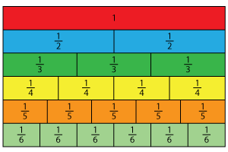
Fraction Strips


© Chris Hurst & Derek Hurrell, 2021
Modified Chris Hurst 2025

Explicit Teaching Task
The purpose of this task is to help students develop a conceptual understanding of equivalent fractions. Students use a set of paper strips to represent given fractions. The materials can be prepared by cutting copy paper cut into strips approximately 2cm. wide. Cutting the sheets in landscape format gives strips 20-21cm. long. The copy paper should be in different colours. A guillotine or paper cutter can be used.
For each part of the activity, engage students in discussion about how to proceed. Make explicit connections to fractions and their equivalents as needed to develop an understanding of the connections that exist between different fractions. Focus on the notion that, if a strip is to show fourths (or quarters) then it must be folded in four parts.
Tasks 1 and 2 are relatively straight forward as the strips can be folded into halves, then halves again, and in the case of Task 2, into halves for a third time.
Tasks 3 and 4 require some estimation to fold the strip into three equal parts (Task 3). It is important that students appreciate that the fractional parts must be equal, or in this case, as close as possible to being equal. Task 4 requires the students to fold the strip into five equal parts which is quite difficult but a worthwhile exercise.

Student Task Sheet

Task 1
The blue strip represents one whole. Fold it to show two halves. Fold it again to show four quarters and label each part with fractions.
Task 2
The green strip represents one whole. Fold it to show two halves. Fold it again to show eight eighths and label each part with fractions.
Task 3
The red strip represents one whole. Fold it to show two halves. Fold it again to show six sixths and label each part with fractions.
Task 4
The yellow strip represents one whole. Fold it to show two halves. Fold it again to show ten tenths and label each part with fractions.

