

© Chris Hurst & Derek Hurrell, 2020

Farms, Sheep, Cows & Fruit Trees


Teacher Notes
The focus of this task is on writing number sentences to match problem semantics, the inverse relationship between multiplication and division, and the division construct for fractions. For each part of the exercise, students should be encouraged to do a drawing to represent the problem. This can be array based and supported by a written explanation. For example . . .
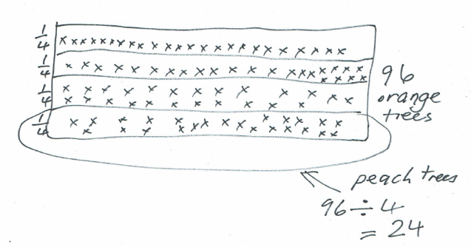

Discussion in pairs and small groups is important for sharing ideas as not all students will have matched the same story and number sentence. An example where three number cards can be matched to the one story follows:
A farmer had 96 sheep and wanted to put them evenly into four pens. How many in each pen?
This story can be matched to three number sentences.
96 ÷ 4 = 24
¼ x 96 = 24
24 x 4 = 96
This requires careful discussion to help children see the connections between the different number sentences and the word story.

Review the concept of writing number sentences to match word stories and vice versa. Use the following array to generate the six number facts (two commutated multiplication facts and their associated division facts, and two linked fraction facts) and make up a word story for each number fact.
For example, ‘There are 15 buses parked in rows. One third are in each row. How many buses are there in each row?’ 1/3 of 15 = 5
Set up the main task - Match each number sentence to one or more of the word stories. Explain why you chose a particular card to match to a problem. Show with a drawing.

Student Task Sheet
96 x 4 = 384
96 ÷ 24 = 4
24 x 4 = 96
¼ x 24 = 6
96 ÷ 4 = 24
¼ x 96 = 24

Word stories
- A farmer had 96 sheep and wanted to put them evenly into four pens. How many in each pen?
- A farmer had 96 sheep in one truck. They were only a quarter of all his sheep. How many did he have altogether?
- A team of four shearers visited the farm and each shore 96 sheep. How many were shorn altogether?
- A farmer had 96 orange trees in his orchard. This is four times as many as his peach trees. How many peach trees does he have?
- A farmer had 24 milking cows and a quarter of them were black. How many were black?
- A farmer had 24 milking cows, but he only had a quarter as many as his neighbour. How many milking cows did his neighbour have?

