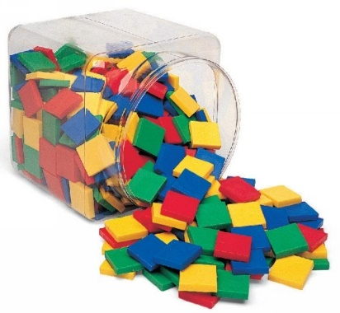

© Chris Hurst & Derek Hurrell, 2020

Amazing Tiles 4

Image retrieved from: https://reebedo.com/wp-content/uploads/2019/04/42571-8.jpg
Explicit Teaching Task
Materials Needed
- Two bags of 36 tiles, each bag of tiles being a different colour. Using the same colours for all children will make the instructions somewhat easier to deliver and clearer for the children to understand.
- Ideally, children should work in pairs or groups of three.

Teaching Stages
- Ask the children to make an array of one colour, as shown.

Through questioning and probing, determine what is understood by the term ‘percentage’. Ask, ‘What percentage of the tiles is yellow?’ Draw out that they are all yellow so that means that 100% of the tiles are yellow. Also draw out that the fraction of the tiles that are yellow is 15/15, or 5/5 in terms of rows.

- Ask the children, “How many tiles make 100% of the array?”
- Ask children, “How many tiles make 50% of the array? 25% 75%?”
- Ask children, “How many tiles make 10% of the array and how did you work that out?” Then ask about 5%, 20%, 35%, 70%.
- Ask, “With this array, what is the rule for finding the number of tiles to make a particular percentage of the array?”

- Ask them to replace one row of the tiles with tiles of another colour.
Ask, ‘What percentage of the tiles is yellow or green?’ Draw out that all the tiles are either yellow or green so 100% of the tiles are yellow or green. Ask how to work out what percentage of the tiles is yellow and what percentage is green. Through probing and questioning, establish what each row must be worth in terms of percentage. That is, the whole array is 100% and there are 5 rows, so each row must be worth 20%. Establish that for the five rows, 20% + 20% + 20% + 20% + 20% = 100%. Therefore, the yellow tiles represent 80% and the green tiles represent 20%.

- At this stage, ask them to consider other ways of expressing the relationships. Draw out, through a consideration of rows, that the yellow tiles represent 4/5 (4 rows out of 5) and the green tiles represent 1/5 (1 row out of 5). Establish that 80% = 4/5 and 20% = 1/5.
- Also, take the opportunity to develop residual thinking. That is, the whole array represents 100% so, if the yellow tiles represent 80%, the green tiles must represent 100% ̶ 80% = 20%, and vice versa.

Teacher Notes
The importance of using hands on materials such as tiles to provide a visual and manipulative representation of ratio should not be underestimated. The materials go a long way to facilitating the development of a conceptual understanding of this important mathematical idea. Failure to use the materials will most likely lead to the development of a procedural knowledge, which may serve to restrict the efficacy of the learning.
Residual thinking
- If we have 1/4 of an object or collection, then there is 3/4 that is not included. The concept of residual thinking is important for comparing and ordering fractions such as 3/4 and 4/5. The ‘residual part’ of each fraction is one part – each fraction is one part less than a whole Because the fifth parts are smaller than the quarters, it means that 4/5 is closer to a whole and therefore larger than 3/4.
- Residual thinking can be applied to percentages as well. That is, if 60% of tiles are of one colour (say red), and the rest are of another colour (say blue), then the blue tiles must be 100% ̶ 60% = 40%.
Percentage
- Arrays can be used to represent percentage. The proportional relationship between the parts can be described in terms of percentages.
- Percentage is often taught solely in terms of it being ‘out of a hundred’ or that ‘percentage means hundredths’. This is a restrictive view of percentage and can lead children to become confused when percentage is used to describe a relationship when there is more or less than one hundred items, which is the case for most of the time. Percentages rarely refer to exactly one hundred items so the teaching of percentage must be broadened to looking at it as a proportional relationship, expressed as a part out of one hundred.

