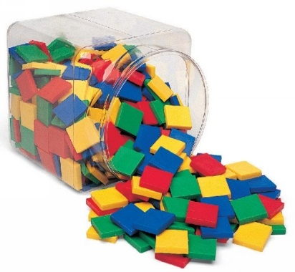

© Chris Hurst & Derek Hurrell, 2020

Amazing Tiles 2

Image retrieved from: https://reebedo.com/wp-content/uploads/2019/04/42571-8.jpg
Explicit Teaching Task
Materials Needed
- Two bags of 24 tiles, each bag of tiles being a different colour. Using the same colours for all children will make the instructions somewhat easier to deliver and clearer for the children to understand.
- Ideally, children should work in pairs or groups of three.
Teaching Stages
- Ask the children to make a six by three array (six rows of three) with one set of tiles.
  - Discuss the array, associated number facts, number sentences etc. that could be written about the array.
Draw out the six associated number facts (two multiplication 6 × 3 = 18, 3 × 6 = 18, two division 18 ÷ 3 = 6, 18 ÷ 6 = 3, two fraction 1/3 of 18 = 6, 1/6 of 18 = 3) through rotating the array. Also draw out the ‘times as many’ links – the whole array is 6 times as many as each row of three, and each row is one sixth as many as the whole array. Also draw out the equivalent fraction relationships – each row is 1/6 or 3/18 of the array.

- Ask them to replace one row with the other colour.
Discuss the meaning of part-to-part ratio, that is, expressing the relationship between the two parts of the whole. Draw out that the part-to-part ratio for red: yellow is 5: 1. That is there are five times as many red tiles as there are yellow tiles. Draw out that the ratio for yellow to red is 1: 5. That is there are one fifth as many yellow tiles as red tiles. It would be a good opportunity to discuss the way that the order of the numbers effects the language used to describe the relationship, that is 5 times as many and one-fifth of.

- Ask them to replace another row of red tiles with yellow tiles.
Draw out that the part-to-part ratio for red: yellow is 4: 2. That is, for four rows of red tiles, there are two rows of yellow tiles. Draw out that the ratio for yellow to red is 2: 4. That is, for every two rows of yellow tiles, there are four rows of red tiles. Also draw out that the red: yellow ratio can be expressed as 2: 1 because there are twice as many red tiles as yellow tiles. The yellow: red ratio is 1: 2 because there are half as many yellow tiles as red tiles.

- Ask them to replace another row of red tiles with yellow tiles. Ask, ‘How does this change the part-to-part ratios?’
Draw out that the part-to-part ratio for red: yellow is 3: 3. That is, for every three rows of red tiles, there are three rows of yellow tiles. Also draw out that the red: yellow ratio can be expressed as 1: 1 because there are the same number of red tiles as yellow tiles. Some children may be able to see (and say) that the red and yellow tiles are each 50% of the total number of tiles.

- Ask the children to make a different array with tiles of one colour and progressively repeat the process of tile replacement. At each stage, they should describe the part-to-part ratio for tiles of each colour.

Teacher Notes
The importance of using hands on materials such as tiles to provide a visual and manipulative representation of ratio should not be underestimated. The materials go a long way to facilitating the development of a conceptual understanding of these important and related mathematical ideas. Failure to use the materials will most likely lead to the development of a procedural knowledge, which may serve to restrict the efficacy of the learning.
Part-to-part ratio
- Arrays can be used to represent part-to-part ratio and part-to-whole ratio. This task concentrates on part-to-part ratio. The part: whole ratio is the most common construct for fractions. In the second array shown, with 5 red rows and 1 yellow row, the part-to-part ratio of red to yellow is 5:1. This can also be seen as 15:3 as there are 15 red tiles and 3 yellow tiles. Children should be encouraged to write the part-to-part ratios in both ways.
- The task is also useful for revising other concepts of associated number facts, ‘times as many’ relationships, and equivalent fractions.

