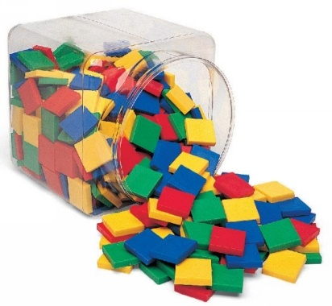

© Chris Hurst & Derek Hurrell, 2020

Amazing Tiles 3

Image retrieved from: https://reebedo.com/wp-content/uploads/2019/04/42571-8.jpg
Explicit Teaching Task
Materials Needed
- Two bags of 36 tiles, each bag of tiles being a different colour. Using the same colours for all children will make the instructions somewhat easier to deliver and clearer for the children to understand.
- Ideally, children should work in pairs or groups of three.
Teaching Stages
- Ask the children to make a 5 × 3 array using tiles of one colour. Ask what fraction of the tiles is blue? Draw out that the blues tiles could be 15/15 or 5/5. If the array is rotated, it could also be 3/3 (that is 3 rows of five). Have them replace one row with the other colour.
Discuss the idea of ‘part-to-whole ratio’, that is, the relationship between the part and the whole. Draw out that for the blue tiles, it is 12:15 because there are 12 blue tiles out of a total of 15. For the yellow tiles, it is 3:15 because there are 3 yellow tiles out of a total of 15. Ask if they can see another way of describing the ratio. That is, in terms of rows, for blue, it is 4:5, because there are 4 rows out of 5 and for yellow, it is 1:5 because there is 1 row out of 5. The part-to-whole ratio is the most common fraction construct and generally written as 4/5 and 1/5.

- Highlight the relationship between this conversation and previous work with common fraction equivalence. Draw out through questioning and prompting that the blue tiles represent 12/15 or 4/5 and the yellow tiles represent 3/15 or 1/5. Check to see if they know that those fraction pairs are called equivalent fractions. If there is any hesitancy in this understanding regarding equivalent fractions, it is advisable to revisit this topic as it is a conceptually important notion.

- Ask them to replace another row of blue tiles with the second colour.
Draw out that for the blue tiles, the part-to-whole ratio is 9:15 because there are 9 blue tiles out of a total of 15. For the yellow tiles, it is 6:15 because there are 6 yellow tiles out of a total of 15. Ask if they can see another way of describing the ratio. That is, in terms of rows, for blue, it is 3:5, because there are 3 rows out of 5 and for yellow, it is 2:5 because there are rows out of 5. That is, they can be written as fractions: 3/5 and 2/5. Relate that to equivalent fractions, that is, 9/15 = 3/5 and 6/15 = 2/5. Also, observe that 9/15 + 6/15 = 15/15 and 3/5 + 2/5 = 5/5 (in terms of rows).

- Now ask them to add some more tiles as shown.
Ask them to describe the array – it is now a 5 by 4 array (5 rows of 4). Draw out that for the blue tiles, the part-to-whole ratio is 12:20 because there are 12 blue tiles out of a total of 20. For the yellow tiles, it is 8:20 because there are 8 yellow tiles out of a total of 20. Ask if they can see another way of describing the ratio. That is, in terms of rows, for blue, it is 3:5, because there are 3 rows out of 5 and for yellow, it is 2:5 because there are rows out of 5. That is, they can be written as fractions – 3/5 and 2/5. Relate that to equivalent fractions, that is, 12/20 = 3/5 and 8/20 = 2/5. Also, observe that 12/20 + 8/20 = 20/20 and 3/5 + 2/5 = 5/5 (in terms of rows).

- Ask the children if they notice anything about the last two arrays, the equivalent fractions, and the ratios. Draw out that the part-to-whole ratios, expressed in terms of rows have not changed. Ask, ‘Why is this?’ Draw out that the tiles of two colours were added in the same proportion. That is 3 blue tiles for every 2 yellow tiles. Similarly, the part-to-part ratios are the same – blue to yellow is 3: 2. Even with the tiles in front of them, some students may require more time to properly embed this understanding. It is a concept that will probably need revisiting on multiple occasions.
- Repeat the process, questioning, and recording for the next three arrays. Ask, ‘What did you notice about the fractions and the ratios?’

Teacher Notes
The importance of using hands on materials such as tiles to provide a visual and manipulative representation of ratio should not be underestimated. The materials go a long way to facilitating the development of a conceptual understanding of this important mathematical idea. Failure to use the materials will most likely lead to the development of a procedural knowledge, which may serve to restrict the efficacy of the learning.
- Using the array to represent part-to-whole ratio.
- Arrays can be used to represent part-to-part ratio and part-to-whole ratio. This task concentrates on part: whole ratio, which is the most common construct for fractions. It also allows a comparison to be made between the two types of ratio.
- Equivalent fractions should be generated at every opportunity in this task and linked to the part-to-whole ratio.
- The strongest point of structure here lies in the third part of the task where more tiles are added in the same proportion as before. The equivalent fractions that are generated change because there are more tiles but the part-to-whole ratio in terms of rows, and tile colours stays the same.

