Equivatiles

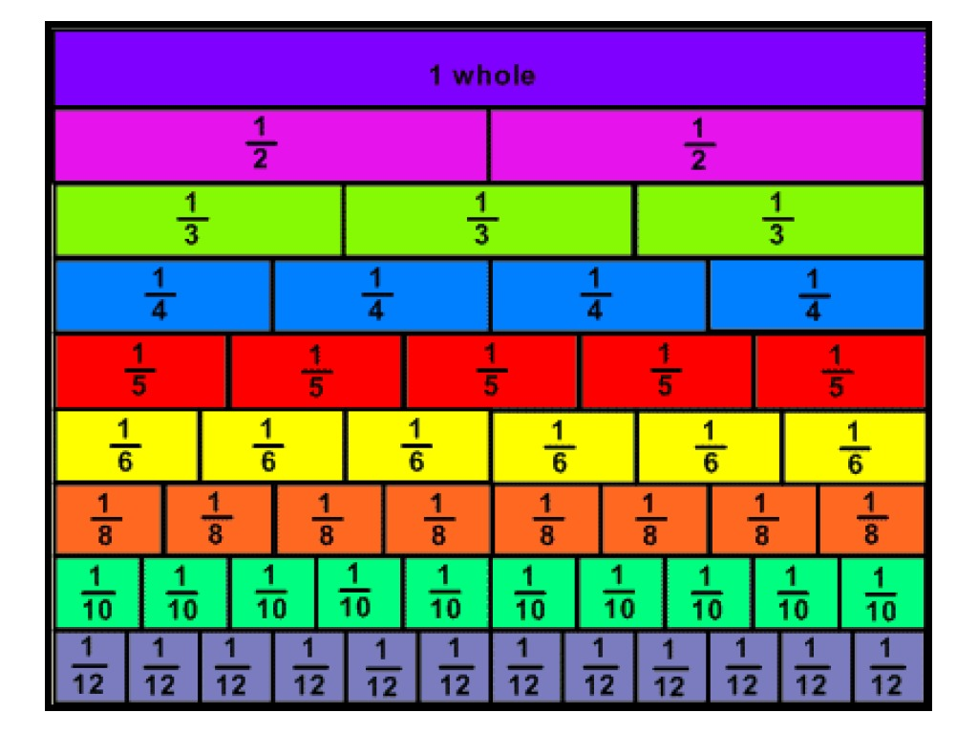

© Chris Hurst & Derek Hurrell, 2022

Explicit Teaching Task
Materials Needed
- Bags of 24 tiles of one colour. Students work in pairs or threes.
- Alternatively, or in addition, grid paper (1 cm square) can be used.
Teaching Stages Part 1
- Make a 4 by 3 array using tiles. Separate one row of tiles. Ask, “What fraction of the array is that?” Establish that it is 1/4 but through discussion, establish that is also 3/12.
- Separate another row and join it to the first. Ask, “What fraction of the array is that now?” Establish that it is 1/2 but through discussion, establish that is also 2/4, and 6/12.
- Separate another row and join it to the first two. Ask, “What fraction of the array is that now?” Establish that it is 3/4 but through discussion, establish that is also 9/12.
- Put the entire array back together. Ask, “What fraction of the array is that now?” Establish that it is 4/4 but through discussion, establish that is also 12/12. Establish that we write it as 1 (for 1 whole).
- Rotate the array to make a 3 by 4 array. Repeat the same lines of questioning as one row at a time is separated. Ask, “What fraction of the array is that?” Establish that one row is 1/3 but through discussion, establish that is also 4/12.
- Separate another row and join it to the first row. Ask, “What fraction of the array is that?” Establish that one row is 2/3 but through discussion, establish that is also 8/12.
- Put the entire array back together. Ask, “What fraction of the array is that now?” Establish that it is 3/3 but through discussion, establish that is also 12/12. Establish that we write it as 1 (for 1 whole). Record it as 1 = 3/3 = 4/4 = 12/12.

Teaching Stages Part 2
- Make a 4 by 5 array using tiles.
- Follow the process described above and work through the responses for a 4 x 5 array and 5 x 4 array.

Teaching Stages Part 3
- Ask students what other arrays could be made to investigate equivalent fractions. Establish that there are quite a few, including 4 by 6 (and 6 by 4), and 3 by 5 ((and 5 by 3)
Teaching Stages Part 4
- Pose the question, “Which is bigger, 2/3 or 3/4? How do you know?” This could generate some good discussion. Respond with, “Let’s see if we can find out by making some arrays”.
- Continuing to work in pairs or small groups, ask students to make a 3 by 4 array with tiles of one colour, and a 4 by 3 array with tiles of another colour, such as:

- Ask students to separate 3 rows of the first (in this case, yellow) array, and two rows of the second (in this case, blue) array. Ask, “What fractions of the arrays do you have?” Establish that they are 3/4 (yellow) and 2/3 (blue). Ask, “Which fraction is bigger? How do you know?”

- Establish through probing questioning and discussion that 3/4 is equivalent to 9/12 and 2/3 is equivalent to 8/12, so therefore 3/4 is bigger.
  - Pose the question, “How can we convert 3/4 into twelfths? What is the relationship between the 3 and the 9 and the 4 and the 12? How many times as big is 12 than 4, and 9 than 3?”
  - Pose the question, “How can we convert 2/3 into twelfths? What is the relationship between the 2 and the 8 and the 3 and the 12? How many times as big is 12 than 3, and 8 than 2?”
  - Explicitly make the link between multiplying the 3 by 3 because there are four rows of three. Similarly, make the link between multiplying the 2 by 4 because there are three rows of four.
Teacher Notes
This task is premised around manipulative materials being crucial in assisting students to develop a conceptual understanding of fraction equivalence. At some stage, students will need to convert fractions to equivalents by using the lowest common multiple or lowest common denominator method. However, before that is introduced, it is important that they learn conceptually by using manipulatives.
Teaching Stage 1 uses the tiles for students to physically see that a fraction such as one half is also equivalent to two quarters and six twelfths. At that first stage, it may be appropriate for teachers to ‘sow the seeds’ for later thinking about common multiples by asking questions like, “What do you notice about the numerators and denominators in the two fractions 1/2 and 2/4?” The discussion can be begun there and concluded in Teaching Stage 4 when students have had further opportunities in Teaching Stages 2 and 3 to work with other fractions.
The foundations of the Lowest Common Multiple/Lowest Common Denominator concept are explored in Teaching Stage 4. The language of factors and multiples comes into play here. Pose explicit questions like, “What is a multiple of 3 and 4?” and “Three and four are factors of what number/s?” To explicitly lead to the idea of the LCD, ask, “What is the lowest multiple for both three and four? That is, what is the lowest number that they will both divide into evenly, or of which they are both factors?” Note that we call that number ‘the lowest common denominator for 3 and 4’.
It is also important to consider residual or gap thinking to compare 2/3 and 3/4. Both fractions are one part less that one whole. For 2/3 it is a third away from one whole while for 3/4, it is a quarter/fourth away from one whole. Since one third is bigger than one quarter/fourth, 2/3 must further away from one whole, or the smaller fraction.

Grids for Tiles (Part Four)

