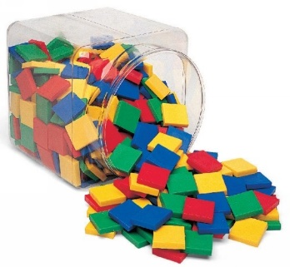
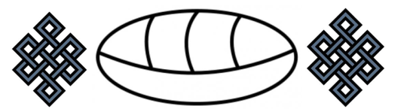
© Chris Hurst & Derek Hurrell, 2022
Modified 2025

Frac Tiles

Task Focus
This task focuses on the first content descriptor about recognising, representing and describing unit fractions, and combining unit fractions with the same denominator to make a whole. The task also begins to develop students’ understanding of the later concept of equivalent fractions. However, an important focus here is for students to understand that a half in one situation can look different to a half in another situation. Residual (or gap) thinking can also be developed in this task. That is, if we have one quarter, there are three quarters that we don’t have.
Materials needed.
- A bag of 20 to 30 tiles of two colours, for example, 12 blue tiles and 12 yellow tiles.
- The children should work in pairs or groups of three.
What the students do . . . a suggested progression
- Begin by asking children what is meant by a half. Draw out that a whole is split into two parts which must be equal. Ask them to make an array of two rows with two different colours to show one half. Depending on children’s experience, a wide range of arrays might be presented including the following:

- Depending on which arrays are made, ask the question, ‘Does each of these arrays show a half? How do you know?’
  - If only the first array is presented, ask, ‘Can anyone use more tiles to show a half?’
  - The purpose here is to have children make a series of arrays with the tiles, and to say, ‘One row is blue, and one row is yellow. Both rows are equal, so each row represents one half’.
  - Ask, “Can we write a number sentence about our arrays?” Develop the idea that ½ + ½ = 2/2 or 1 whole. Similarly, for quarters, that 2/4 + 2/4 = 4/4 or 1 whole.

- Ask children what is meant by one third. Draw out that a whole is split into three parts which must be equal. Ask them to make an array of three rows with two different colours to show one third. Depending on children’s experience, a wide range of arrays might be presented including the following:

- Depending on which arrays are made, ask the question, ‘Does each of these arrays show one third? How do you know?’
  - If only the first array is presented, ask, ‘Can anyone use more tiles to show one third?’
  - The purpose here is to have children make a series of arrays with the tiles, and to say, ‘There are three rows, and they are equal, so each row must equal one third’.
  - The idea of residual thinking can also be developed here. Draw out that the yellow tiles represent 1/3 and the blue tiles represent 2/3. Hence, 1/3 + 2/3 = 3/3 or 1 whole.
- This process can be repeated by asking children what they understand by one fourth or one quarter and following the same steps. This can be followed by repeating the same ideas for one fifth and one tenth (more tiles will be needed to show a range of arrays showing one tenth).

Teacher Notes
The importance of using hands on materials such as tiles to provide a visual and manipulative representation of fractions should not be underestimated. The materials go a long way to facilitating the development of a conceptual understanding of this important mathematical idea. Failure to use the materials will most likely lead to the development of a procedural knowledge, which may serve to restrict the efficacy of the learning.

There is no specific Student Task Recording Sheet for this task. However, students can be asked to draw each of the arrays they make. Grid paper (1 sq. cm.) could be used to do this.

Key features of this task are:
- Using the array to represent fractions.
- Halves can still be halves even though they may look different.
- The idea of residual thinking in that if we have 1/4 of an object or collection, then there is 3/4 that is not included.
- The later concept of equivalent fractions can be represented with arrays.
- This task is laying the foundations for proportional reasoning as children see that for each of the arrays showing one half, the tiles still show one half even though there are more tiles in succeeding arrays. The same occurs for the arrays showing one third, one fourth and so on.

