Dinosaur Maths


© Chris Hurst & Derek Hurrell, 2021

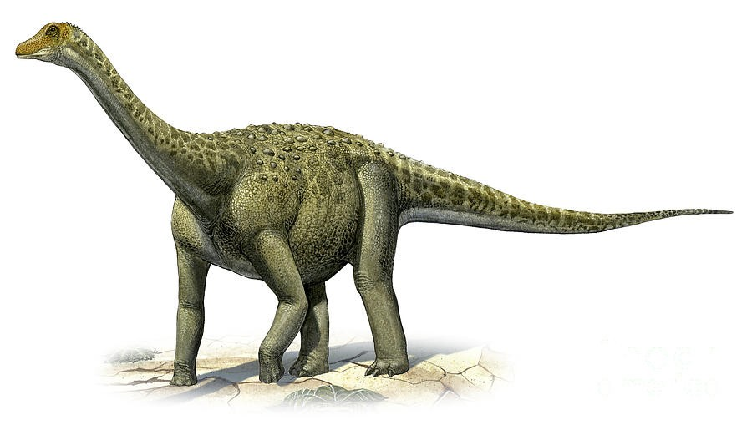

Materials Needed
- Copy of the student task sheets.
- Copy of the table containing animal statistics

Initially, there are two investigative tasks.
- A small Hummingbird weighs as little as 3 grams.
- An extinct Titanosaur weighed 150 tonnes.
- How many times as heavy as the Hummingbird would a Titanosaur have been?

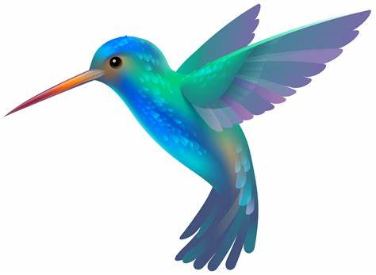

- The Argentinosaurus dinosaur was 40 metres long.
- The Epidexipteryx dinosaur was 25cm long.
- How many times as long was Argentinosaurus compared to Epidexipteryx?

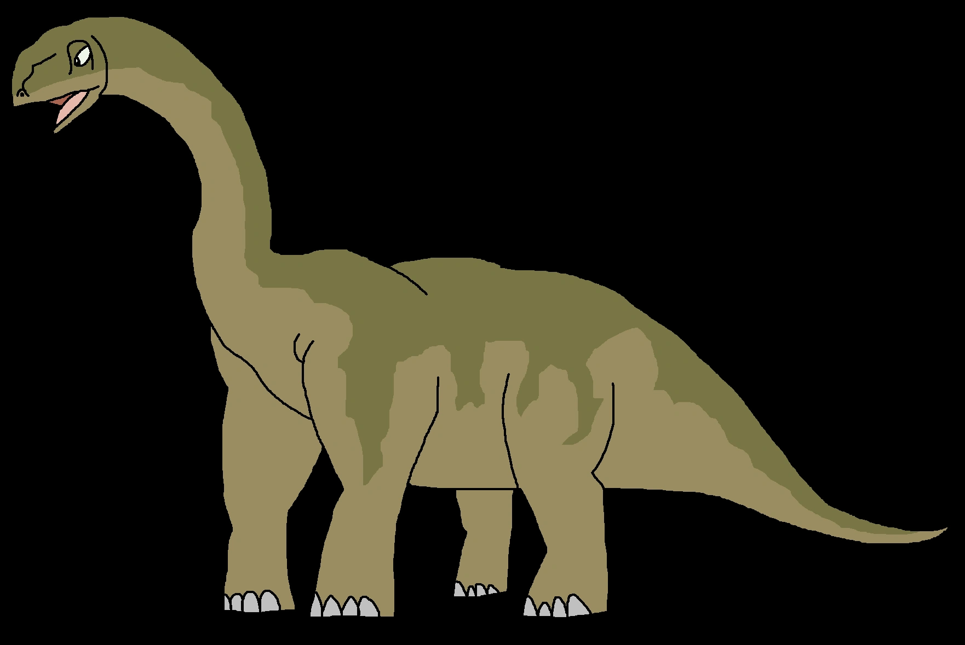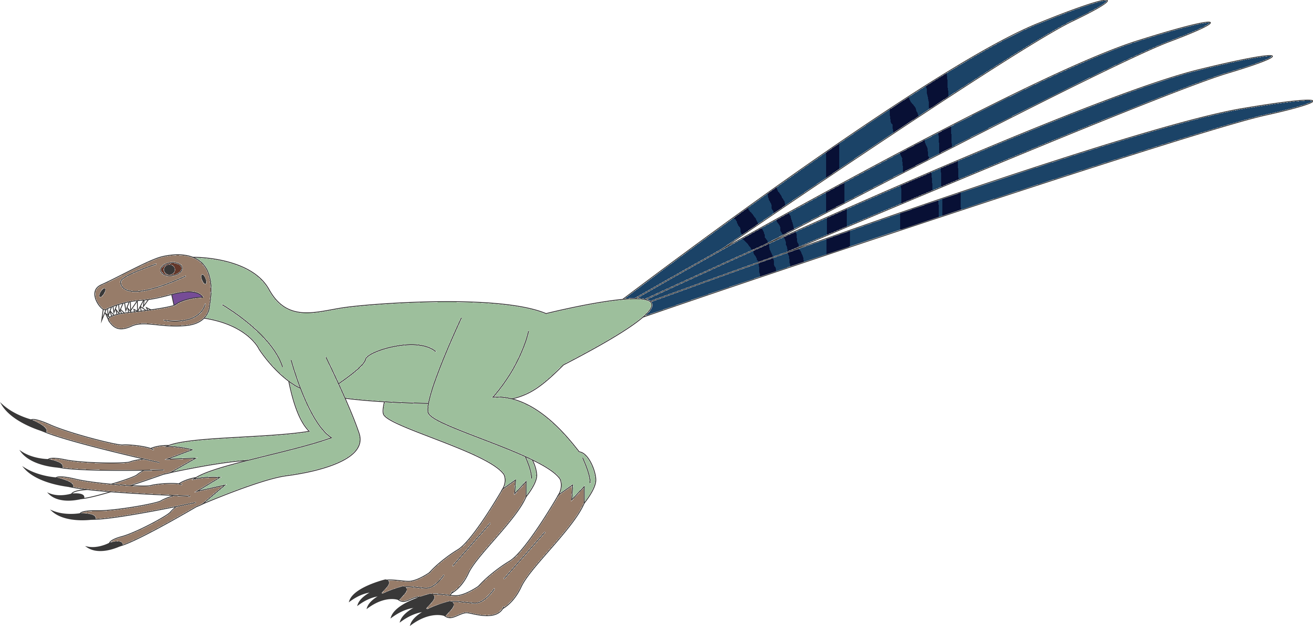
Investigate!

The following table contains information about animals that inhabit the earth. Make up some ‘times as long’, ‘times as tall’, or ‘times as heavy’ statements using the information and show how you would work out each relationship.

Animal | Mass | Length
Great White Shark | 600 kg | 7 m
Japanese Spider Crab | 18 kg | 6 m
Giant Manta Ray | 3 T | 10 m
Orca | 5 T | 9 m
Whale Shark | 20 T | 11 m
Sperm Whale | 60 T | 22 m
Blue Whale | 150 T | 27 m
Rhinoceros | 3 T | 4 m
Hippopotamus | 4 T | 5 m
Yak | 700 kg | 2.5 m
Moose | 400 kg | 2.5 m
Grizzly Bear | 300 kg | 2 m
Orangutan | 60 kg | 1 m
Red Kangaroo | 50 kg | 1.5 m
Leopard | 50 kg | 2 m
Hairy-nosed Wombat | 30 kg | 1 m
Siberian Musk Deer | 10 kg | 1 m
Long-nosed Echidna | 8 kg | 60 cm
Three-toed Sloth | 4 kg | 50 cm
Gray Fox | 5 kg | 90 cm
Mongoose | 2 kg | 60 cm
Southern Brown Bandicoot | 1 kg | 50 cm
Boa Constrictor | 30 kg | 4 m
Cobra | 10 kg | 4 m
Anaconda | 200 kg | 8 m
Giant Weta (N.Z. Cricket) | 70 g | 10 cm
Atlas Moth | 30 g | 10 cm
Elephant Beetle | 90 g | 13 cm
Praying Mantis | 6 g | 18 cm
Atlantic Cod | 100 kg | 2 m
Spanish Mackerel | 70 kg | 2.5 m
Black Swan | 8 kg | 120 cm
Stubble Quail | 100 g | 18 cm
Sharp-tailed Sandpiper | 70 g | 20 cm
Gentoo Penguin | 8 kg | 90 cm
Pink and Grey Galah | 300 g | 30 cm
Willie Wagtail | 20 g | 20 cm

Student Task Sheet
- A small Hummingbird weighs as little as 3 grams.
- An extinct Titanosaur weighed 150 tonnes.
- How many times as heavy as the Hummingbird would a Titanosaur have been?

- The Argentinosaurus dinosaur was 40 metres long.
- The Epidexipteryx dinosaur was 25cm long.
- How many times as long was Argentinosaurus compared to Epidexipteryx?

Teacher Notes
This is an engaging task and children should be encouraged to use a method that makes sense to them. It is a good task to further develop the language around the ‘times as many’ concept. In this task, the language is ‘times as long’, ‘times as big’, ‘times as tall’ etc. The opportunity exists here to use focused questions and enabling prompts. Ideally, students should work in pairs or small groups of three or four.
Initial questioning could take the form of, “What do you think you might use to help you come to an answer?” and “What might you need to do with the numbers and units in order to compare them?”
One way that the ‘hummingbird problem’ can be solved is as follows:
• The Hummingbird’s weight is 3 grams
• Multiplying it by 1000 makes it 3000 grams or 3 kilograms
• 3 kilograms multiplied by 1000 makes it 3000 kilograms or 3 tonnes
• 3 tonnes multiplied by 50 makes it 150 tonnes.
• Therefore, the Titanosaur is 50 × 1000 × 1000 (or 5 × 10 × 10 × 10 × 10 × 10 × 10 × 10) times as heavy as the Hummingbird! That is 50 000 000 times as heavy!
The ‘argentinosaurus problem’ can be solved in a similar way.
When using the table of statistics, children have an open choice of which information to use. Again, discussion and sharing ideas is essential. There is opportunity here to develop proportional reasoning. For example, a student might note that the Leopard is five times as heavy as a Siberian Musk Deer, but only two times as long.

