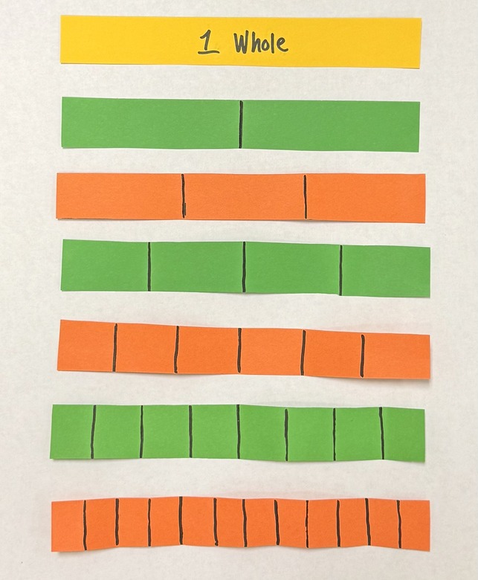
Fraction Strips


© Chris Hurst, 2023
Modified 2026

Explicit Teaching Task
Materials Needed
- Paper strips for folding.
- Glue sticks
- Recording page (A3) for pasting the strips and for marking the fractions.
The purpose of this task is to help students develop a conceptual understanding of fractions, equivalent fractions, and how they can be ordered. Students use proportional reasoning to make a set of paper strips to represent given fractions. The materials can be prepared by cutting copy paper cut into strips approximately 2cm. wide. The blue and green strips should be cut along the length of the A4 sheets (just under 30cm. long). A guillotine or paper cutter can be used.

For each part of the activity, engage students in discussion about how to proceed. Make explicit connections to equivalent fractions as needed to develop an understanding of the connections that exist between the ideas of fraction size, equivalence, and ordering.

Task 1
The blue strip represents 1 whole. Fold the blue strip to represent 1/2, 1/4, and 1/8
Pose questions like, “How do we fold the strip to show one half?” Follow this question with similar questions about folding it again, and then again to show quarters and then eighths.
Task 2
The green strip represents 1 whole. Fold the green strip to represent 1/2, 1/3, 1/4, 1/6, and 1/12.
Pose questions like, “How is the folding of this green strip different and similar to the folding of the blue strip?” Derive the idea that initially it can either be folded in half to make two halves or folded into three parts to make thirds. If folding in halves, it can then be folded into halves again (to make quarters) and then into three parts to make twelfths. If the initial fold is into three parts, it can be folded in half and then in half again to make sixths and then twelfths. It is likely that this part of the task will take some time to consolidate the understanding. The difficulty of folding into thirds can be a good point of discussion with the ultimate realisation that, if the fold is close to being accurate, it is satisfactory.
Recording Stage.
Using the blank A3 page, students should then align the left end of each strip and paste the strips about 4cm. apart. The folds on the folded strips can then be marked as shown here.

 |  |  |  |  |  |  |  | 1/2 2/2
1/4 |  |  |  |  |  |  |  | 2/4 3/4 4/4
1/8 2/8 3/8 |  |  |  |  |  |  |  | 4/8 5/8 6/8 7/8 8/8
1/12 2/12 3/12 4/12 5/12 6/12 7/12 8/12 9/12 10/12 11/12 12/12

