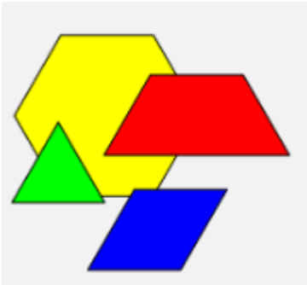
Fraction Blocks

This task was inspired by similar activities in Pattern Blocks, by Paul Swan and Geoff White.

Explicit Teaching Task
How many ways can you cover a yellow hexagon pattern block with a combination of red trapezoids, blue rhombuses, and green triangles?
Teaching Stages
- Introduce the task by discussing the four pattern blocks. Have the children do a think-pair-share and discuss the shape names, numbers of sides, angles etc. Ask, “How big is each pattern block compared to the others?”
- Set the main task - How many ways can you cover a yellow hexagon pattern block with a combination of red trapezoids, blue rhombuses, and green triangles?
- Ask, “How many ways do you think there might be?”
- Children work in pairs or groups of three. As a combination for covering the hexagon is found, it is traced onto paper and shaded.
- Once the children have been working for a while, ask some prompting questions like, “Has anyone found a way of covering the hexagon with three different shapes?”
- Again, ask the question, “How many ways do you think there might be now?”
- Once the activity subsides a little, call the children together and share the combinations of shapes they have made. There are seven combinations for covering the hexagon, shown below.

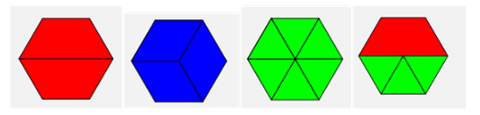
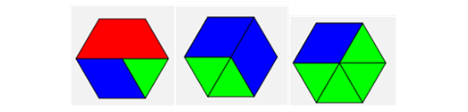
- Follow up on the earlier question about the relative sizes of the blocks.
  - Establish through prompting and questioning that the hexagon is one whole, so the red trapezoid must be 1/2, the blue rhombus is 1/3, and the green triangle is 1/6.
- Ask, “How can we record what we did when we made the shape combinations?” For example, “What could we write about the two red trapezoids?”
  - Use prompts to draw out that it shows
1 | + | 1 | = | 2 | = | 1
2 | + | 2 | = | 2 | = | 1
- Ask children to record their working for each of the other combinations where one shape is repeated (three blue rhombuses and 6 green triangles).
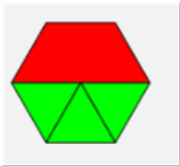
- Refer to the shape comprised of the trapezoid and three triangles. Ask, “If we covered a red trapezoid with green triangles, what is another way that we could name the trapezoid?” Draw out 3/6.
  - Use prompts to arrive at the working below.
1 | + | 3 | = | 3 | + | 3 | = | 6 | = | 1
2 | + | 6 | = | 6 | + | 6 | = | 6 | = | 1
- Ask children to suggest how they could record their working for the other shapes.

- Refer to the combination of the three shapes. Re-establish the value of the blue rhombus at 1/3. Ask, “If we could cover the blue rhombus with green triangles, what is another way we could name the rhombus?” Draw out 2/6.
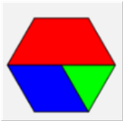
  - Use prompts to arrive at the working below.
1 | + | 1 | + | 1 | = | 3 | + | 2 | + | 1 | = | 6 | = | 1
2 | + | 3 | + | 6 | = | 6 | + | 6 | + | 6 | = | 6 | = | 1

2 | + | 2 | = | 4 | + | 2 | = | 6 | = | 1
3 | + | 6 | = | 6 | + | 6 | = | 6 | = | 1
- The working for the other combinations are as follows.
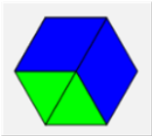

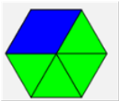
1 | + | 4 | = | 2 | + | 4 | = | 6 | = | 1
3 | + | 6 | = | 6 | + | 6 | = | 6 | = | 1

Teachers Notes
This task highlights just how important it is to use manipulatives like pattern blocks when teaching fractions. The fact that the blocks can be overlayed in one another is very useful and enables children to see the equivalence. The recording of each combination by tracing is important as it reinforces the understanding. This task is effective in overcoming the common misconception that children develop when initially adding fractions. That is, the misconception is that they add the numerators and the denominators. It is clear to them when doing this task that the denominators are not added. It is important to reinforce this by using appropriate language. For the first combination of multiple shapes, ask, “If we have 3 sixths and 3 more sixths, how many sixths do we have altogether?”

