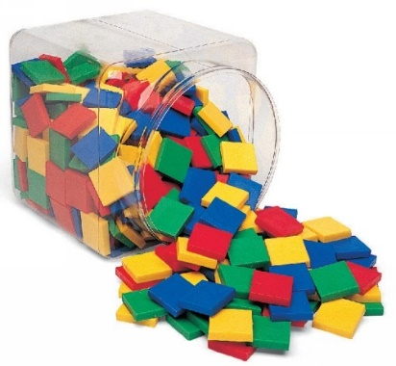

© Chris Hurst & Derek Hurrell, 2020

Amazing Tiles 5

Explicit Teaching Task
Materials Needed
- Two bags of 36 tiles, each bag of tiles being a different colour. Using the same colours for all children will make the instructions somewhat easier to deliver and clearer for the children to understand.
- Ideally, children should work in pairs or groups of three.
Teaching Stages
- Ask the children to make an array of one colour, as shown.
Through questioning and probing, determine what is understood by the term ‘percentage’. Ask, ‘What percentage of the tiles is yellow?’ Draw out that they are all yellow so that means that 100% of the tiles are yellow. Also draw out that the fraction of the tiles that are yellow is 15/15, or 5/5 in terms of rows.

- Ask them to replace one row of the tiles with tiles of another colour.
Ask, ‘What percentage of the tiles is yellow or green?’ Draw out that all of the tiles are either yellow or green so 100% of the tiles are yellow or green. Ask how to work out what percentage of the tiles is yellow and what percentage is green. Through probing and questioning, establish what each row must be worth in terms of percentage. That is, the whole array is 100% and there are 5 rows, so each row must be worth 20%. Establish that for the five rows, 20% + 20% + 20% + 20% + 20% = 100%. Therefore, the yellow tiles represent 80% and the green tiles represent 20%.

- At this stage, ask them to consider other ways of expressing the relationships. Draw out, through a consideration of rows, that the yellow tiles represent 4/5 (4 rows out of 5) and the green tiles represent 1/5 (1 row out of 5). Establish that 80% = 4/5 and 20% = 1/5.
- Also, take the opportunity to develop residual thinking. That is, the whole array represents 100% so, if the yellow tiles represent 80%, the green tiles must represent 100% ̶ 80% = 20%, and vice versa.
- Ask them to replace another row of yellow tiles with green tiles.
Re-establish that each row must be worth 20% of the total tiles. That is, the whole array is 100% and there are 5 rows, so each row must be worth 20%. Establish that the green tiles must be worth 20% + 20% = 40%. Also, the yellow tiles must be worth 20% + 20% + 20% = 60%. In terms of residual thinking, consider this as knowing that 40% of the tiles are green and the rest are yellow, then it follows that the yellow tiles must be 100% ̶ 40% = 60%

- Ask them to add some more green and yellow tiles as shown.
Ask, ‘What is the percentage of green and yellow tiles now? Have the percentages changed? Are they still the same? How do you know?
Some useful probing discussion can be had here to establish that the ratio of green tiles to yellow tiles has not changed. That is, the part-to-part ratio is still 2: 3 (or 3: 2 for yellow to green). Again, this can be seen as equivalent fractions. In the previous array, the green tiles represented 6/15 of the total (or 2/5) and the yellow tiles represented 9/15 (or 3/5) of the total tiles. In this array (five by four), the green still represents 2/5 (2 rows) and the yellow tiles represent 3/5 (3 rows). In terms of percentages, the two green rows still represent 40% and the three yellow rows still represent 60%.

- Continue to develop the thinking by adding another two green tiles and three yellow tiles, then repeat again, and again. Consolidate the idea that the percentage of each colour has not changed. Establish that percentage is a proportional relationship and not dependent on the number in the whole.

Teacher Notes
The importance of using hands on materials such as tiles to provide a visual and manipulative representation of ratio should not be underestimated. The materials go a long way to facilitating the development of a conceptual understanding of this important mathematical idea. Failure to use the materials will most likely lead to the development of a procedural knowledge, which may serve to restrict the efficacy of the learning.
Residual thinking
- If we have 1/4 of an object or collection, then there is 3/4 that is not included. The concept of residual thinking is important for comparing and ordering fractions such as 3/4 and 4/5. The ‘residual part’ of each fraction is one part – each fraction is one part less than a whole. Because the fifth parts are smaller than the quarters, it means that 4/5 is closer to a whole and therefore larger than 3/4.
- Residual thinking can be applied to percentages as well.
Percentage
- Arrays can be used to represent percentage. The proportional relationship between the parts can be described in terms of percentages.
- Percentage is often taught solely in terms of it being ‘out of a hundred’ or that ‘percentage means hundredths’. This is a restrictive view of percentage and can lead children to become confused when percentage is used to describe a relationship when there is more or less than one hundred items, which is the case for most of the time. Percentage rarely refers to exactly one hundred items so the teaching of percentage must be broadened to looking at it as a proportional relationship, expressed as a part out of one hundred.
- Another aspect of percentage that can be confusing is when an increase or decrease is expressed in percentage terms. For example, it can be said that the population has increased by 100%, which means it has doubled. However, to return it to its original number, it must be reduced by 50% or half. The key understanding here is, ‘What is the whole in each case?’

